**Topics: Descriptive Statistics and Probability**

1. Look at the data given below. Plot the data, find the outliers and find out $μ, σ, σ^{2}$

|  |  |
| --- | --- |
| **Name of company** | **Measure X** |
| Allied Signal | 24.23% |
| Bankers Trust | 25.53% |
| General Mills | 25.41% |
| ITT Industries | 24.14% |
| J.P.Morgan & Co. | 29.62% |
| Lehman Brothers | 28.25% |
| Marriott | 25.81% |
| MCI | 24.39% |
| Merrill Lynch | 40.26% |
| Microsoft | 32.95% |
| Morgan Stanley | 91.36% |
| Sun Microsystems | 25.99% |
| Travelers | 39.42% |
| US Airways | 26.71% |
| Warner-Lambert | 35.00% |

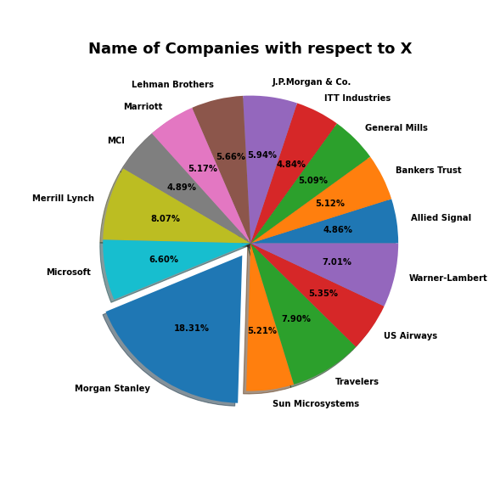

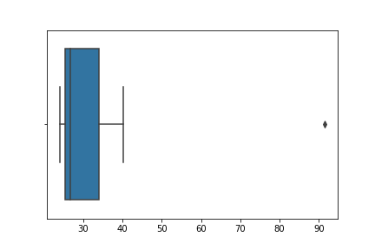

The following is the outlier in the boxplot: Morgan Stanley 91.36%

measure_x.describe()

Mean = 33.271333

Standard deviation = 16.945401

measure_x.var()

Variance = 287.1466123809524



Answer the following three questions based on the box-plot above.

1. What is inter-quartile range of this dataset? (please approximate the numbers) In one line, explain what this value implies.

Q 3 -Q 1 = 12-5 = 7.

1. What can we say about the skewness of this dataset?

Right Skewed.

1. If it was found that the data point with the value 25 is actually 2.5, how would the new box-plot be affected?

As the value 2.5 is not as extreme as the original outlier value of 25, it will not be considered an outlier and will not be plotted as a point outside the whiskers.



Answer the following three questions based on the histogram above.

1. Where would the mode of this dataset lie?

The mode of this data set lie in between 5 to 10 and approximately between 4 to 8 .

1. Comment on the skewness of the dataset.

Right-Skewed. Mean>Median>Mode

1. Suppose that the above histogram and the box-plot in question 2 are plotted for the same dataset. Explain how these graphs complement each other in providing information about any dataset.

They both are right-skewed and both have outliers the median can be easily visualized

in box plot where as in histogram mode is more visible.

1. AT&T was running commercials in 1990 aimed at luring back customers who had switched to one of the other long-distance phone service providers. One such commercial shows a businessman trying to reach Phoenix and mistakenly getting Fiji, where a half-naked native on a beach responds incomprehensibly in Polynesian. When asked about this advertisement, AT&T admitted that the portrayed incident did not actually take place but added that this was an enactment of something that “could happen.” Suppose that one in 200 long-distance telephone calls is misdirected. What is the probability that at least one in five attempted telephone calls reaches the wrong number? (Assume independence of attempts.)

Ans: Probability of a successful call (i.e., not misdirected) is p = 1 - 1/200 = 199/200

Probability of a misdirected call is q = 1/200

Probability of all five calls being successful is:

P(all successful) = (199/200)^5

P(at least one misdirected) = 1 - P(all successful)

= 1 - (199/200)^5 = 0.024 or 2.4%

1. Returns on a certain business venture, to the nearest $1,000, are known to follow the following probability distribution

|  |  |
| --- | --- |
| x | P(x) |
| -2,000 | 0.1 |
| -1,000 | 0.1 |
| 0 | 0.2 |
| 1000 | 0.2 |
| 2000 | 0.3 |
| 3000 | 0.1 |

1. What is the most likely monetary outcome of the business venture?

From the table, we can say that the outcome with the highest probability is 2000, with a probability of 0.3

1. Is the venture likely to be successful? Explain

+ve x values are successful so taking 1000,2000 and 3000.

Probability values are 0.2,0.3,0.1. so P= 0.2+0.3+0.1 = 0.6 > 0.5(p value).so it is

successful.

1. What is the long-term average earning of business ventures of this kind? Explain

Expected value = (-2000) * 0.1 + (-1000) * 0.1 + 0 * 0.2 + 1000 * 0.2 + 2000 * 0.3 + 3000 * 0.1 = $800

Therefore, the long-term average earning of business ventures of this kind is $800.

1. What is the good measure of the risk involved in a venture of this kind? Compute this measure

Risk of venture

Var(X)=E(X 2 )-[E(X)] 2

= 2800000-(800) 2

= 2160000 (Quite high)

Std = sqrt(var) = sqrt(2160000)

Std = 1470$

When variate is high then risk is high.